Exp 5 for 4 bit ALU
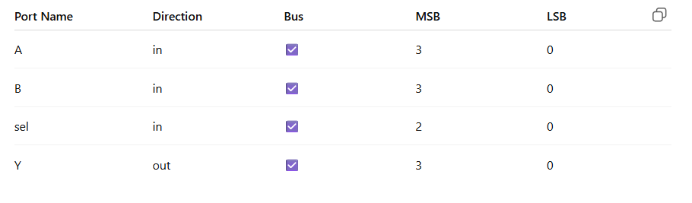

library IEEE;
use IEEE.STD_LOGIC_1164.ALL;
use IEEE.NUMERIC_STD.ALL;

entity alu_4bit is
Port (
A : in STD_LOGIC_VECTOR (3 downto 0);
B : in STD_LOGIC_VECTOR (3 downto 0);
sel : in STD_LOGIC_VECTOR (2 downto 0);
Y : out STD_LOGIC_VECTOR (3 downto 0)
);
end alu_4bit;

architecture Behavioral of alu_4bit is
begin

process(A, B, sel)
begin
case sel is
when "000" => Y <= std_logic_vector(unsigned(A) + unsigned(B));
when "001" => Y <= std_logic_vector(unsigned(A) - unsigned(B));
when "010" => Y <= A AND B;
when "011" => Y <= A NAND B;
when "100" => Y <= A XOR B;
when "101" => Y <= A XNOR B;
when "110" => Y <= A OR B;
when "111" => Y <= A;
when others => Y <= (others => '0');
end case;
end process;

end Behavioral;

Test bench code
LIBRARY ieee;
USE ieee.std_logic_1164.ALL;
USE ieee.numeric_std.ALL;

ENTITY alu_tb IS
END alu_tb;

ARCHITECTURE behavior OF alu_tb IS

-- Component Declaration
COMPONENT alu_4bit
PORT(
A : IN std_logic_vector(3 downto 0);
B : IN std_logic_vector(3 downto 0);
sel : IN std_logic_vector(2 downto 0);
Y : OUT std_logic_vector(3 downto 0)
);
END COMPONENT;

-- Inputs
signal A : std_logic_vector(3 downto 0) := (others => '0');
signal B : std_logic_vector(3 downto 0) := (others => '0');
signal sel : std_logic_vector(2 downto 0) := (others => '0');

-- Output
signal Y : std_logic_vector(3 downto 0);

BEGIN

-- UUT
uut: alu_4bit PORT MAP (
A => A,
B => B,
sel => sel,
Y => Y
);

PROCESS
BEGIN

-- Test values (4-bit)
A <= "1011"; -- 11
B <= "0100"; -- 4

sel <= "000"; wait for 20 ns; -- ADD
sel <= "001"; wait for 20 ns; -- SUB
sel <= "010"; wait for 20 ns; -- AND
sel <= "011"; wait for 20 ns; -- NAND
sel <= "100"; wait for 20 ns; -- XOR
sel <= "101"; wait for 20 ns; -- XNOR
sel <= "110"; wait for 20 ns; -- OR
sel <= "111"; wait for 20 ns; -- PASS A

wait;

END PROCESS;

END;

